Aim: To create a REST API using TypeScript and MongoDB and perform CRUD operations.

Code (server.ts)
import express, { Request, Response } from "express";
import mongoose from "mongoose";
import strawhatRoutes from "./routes/strawhatRoutes";

const app = express();
const PORT = 5000;

app.use(express.json());

app.get("/", (req: Request, res: Response) => {
res.json({
message: "One Piece - Strawhat Pirates API",
version: "1.0.0",
endpoints: {
"GET /strawhats": "Get all Strawhat members",
"POST /strawhats": "Add new Strawhat member",
"GET /strawhats/:id": "Get member by ID",
"GET /strawhats/name/:name": "Get member by name",
"GET /strawhats/role/:role": "Get members by role",
"GET /strawhats/bounty/top": "Get members sorted by bounty",
"PUT /strawhats/:id": "Update member",
"PATCH /strawhats/:id/bounty": "Update bounty only",
"PATCH /strawhats/:id/alias": "Update alias only",
"DELETE /strawhats/:id": "Remove member",
},
});
});

app.use("/strawhats", strawhatRoutes);

app.use((req: Request, res: Response) => {
res.status(404).json({ error: "Route not found" });
});

const connectDB = async () => {
try {
const mongoURI = "mongodb://127.0.0.1:27017/onepiece";

if (!mongoURI) {
throw new Error(
"MONGODB_URI is not defined in environment variables",
);
}

console.log("Attempting to connect to MongoDB...");

const options = {
serverSelectionTimeoutMS: 5000,
socketTimeoutMS: 45000,
family: 4,
retryWrites: true,
retryReads: true,
maxPoolSize: 10,
};

await mongoose.connect(mongoURI, options);
console.log("Connected to MongoDB successfully!");
console.log(
`Database: ${mongoose.connection.db?.databaseName || "Unknown"}`,
);
} catch (error) {
console.error("Failed to connect to MongoDB:");
console.error(error);

console.log("Retrying connection in 5 seconds...");
setTimeout(connectDB, 5000);
}
};

mongoose.connection.on("connected", () => {
console.log("Mongoose connected to MongoDB");
});

mongoose.connection.on("error", (err) => {
console.error("Mongoose connection error:", err);
});

mongoose.connection.on("disconnected", () => {
console.log("Mongoose disconnected. Attempting to reconnect...");
});

const startServer = async () => {
await connectDB();

app.listen(PORT, () => {
console.log(`Server running on http://localhost:${PORT}`);
console.log(`Strawhat API: http://localhost:${PORT}/strawhats`);
});
};

process.on("SIGINT", async () => {
await mongoose.connection.close();
console.log("MongoDB connection closed through app termination");
process.exit(0);
});

startServer();

export default app;

Code (/models/Strawhat.ts)

import mongoose from "mongoose";

const strawhatSchema = new mongoose.Schema(
{
name: {
type: String,
required: true,
trim: true,
},
role: {
type: String,
required: true,
enum: [
"Captain",
"Swordsman",
"Navigator",
"Sniper",
"Cook",
"Doctor",
"Archaeologist",
"Shipwright",
"Musician",
"Helmsman",
],
},
age: {
type: Number,
min: 0,
max: 200,
},
bounty: {
type: Number,
default: 0,
min: 0,
},
alias: {
type: String,
trim: true,
},
gender: {
type: String,
enum: ["Male", "Female", "Other"],
required: true,
},
},
{
timestamps: true,
},
);

export default mongoose.model("Strawhat", strawhatSchema);

Output:
Added data to the collection ‘strawhats’
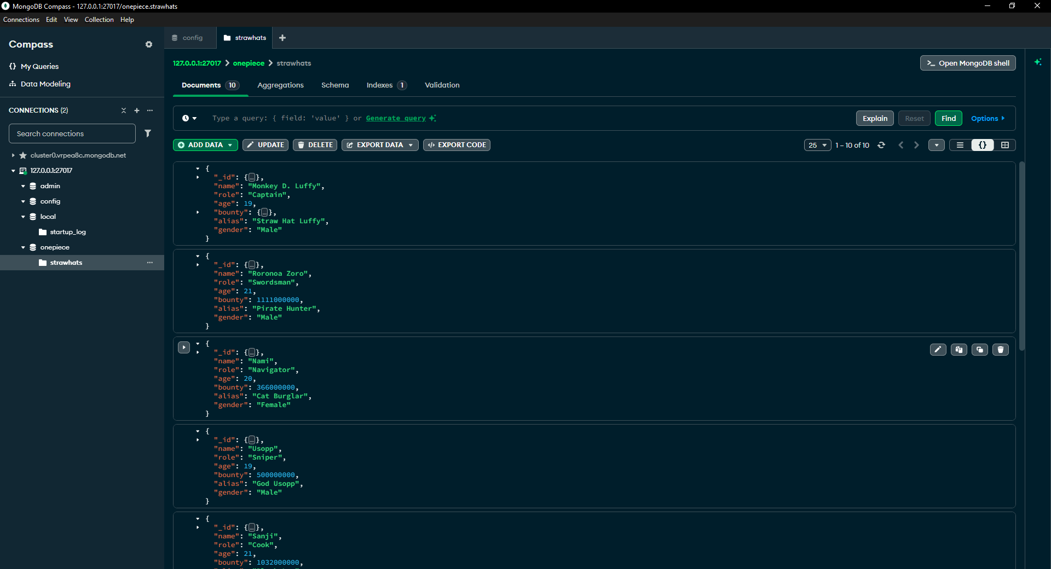

Fetched all strawhats
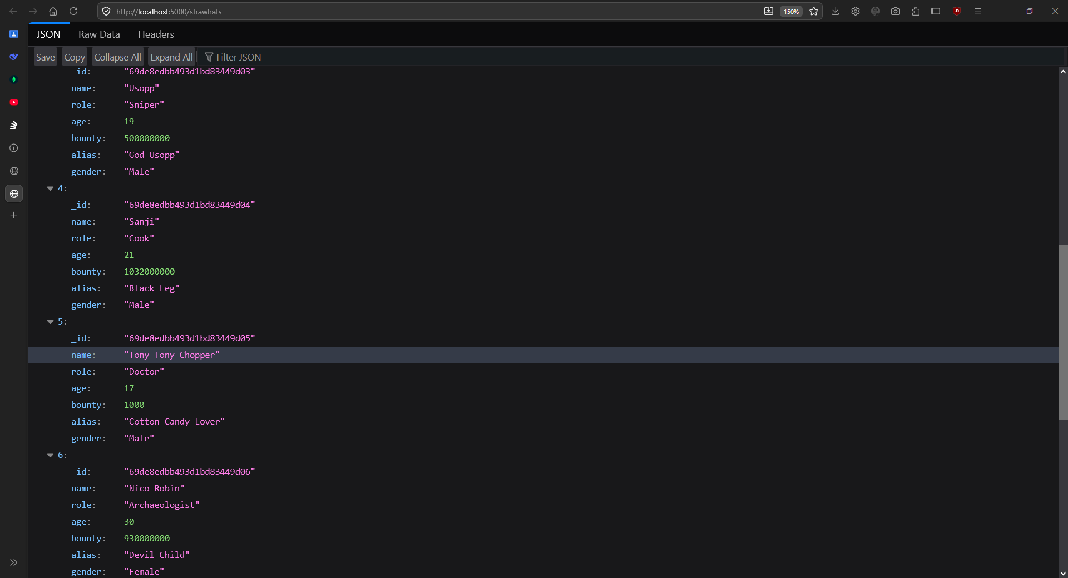

Fetched by highest bounty sort
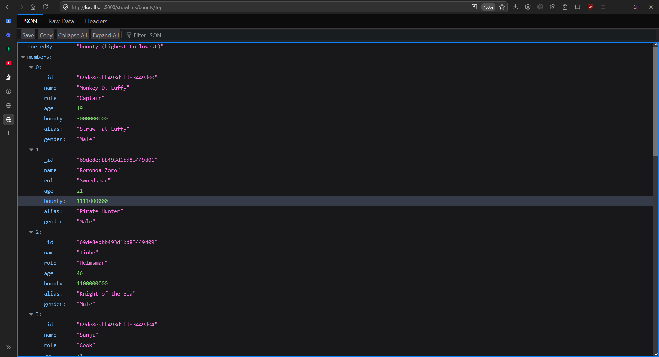

Fetched by id
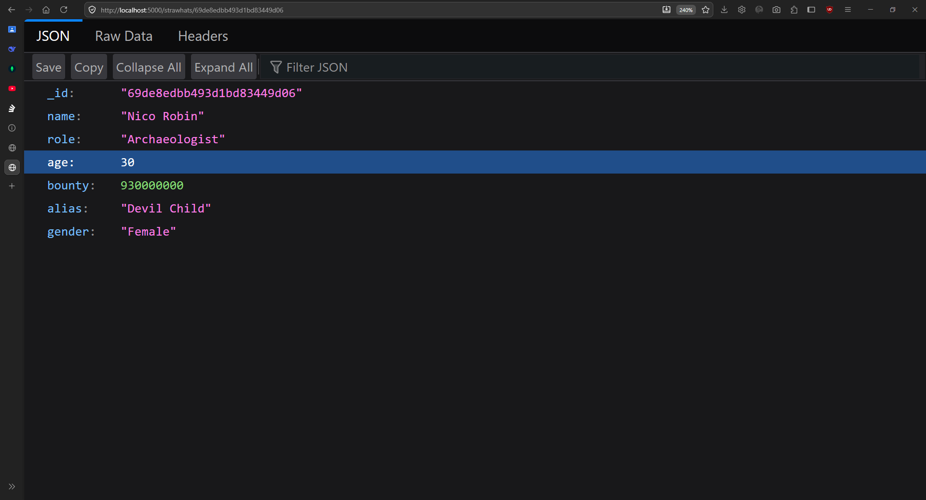

Fetched by role
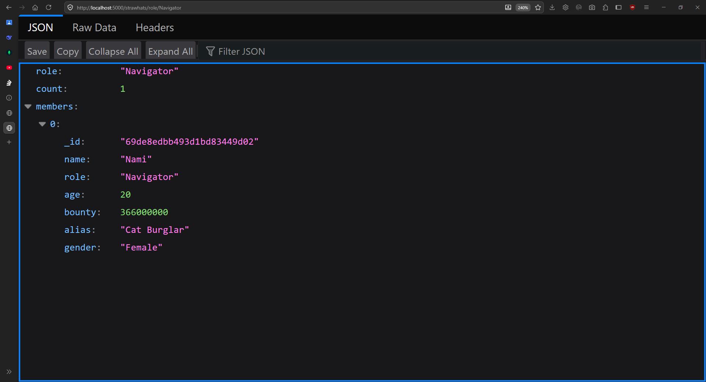

Conclusion:
The experiment demonstrates how to build a REST API using TypeScript and MongoDB and perform database operations.

